15.23: a) 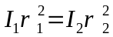

b)

Energy = 